Theme: Solar System
Grade Level: 3rd

EXAMPLE!!!!!

Fine Arts Portfolio

ART:
Painting

“Balloon Universe” by Bri Buckley
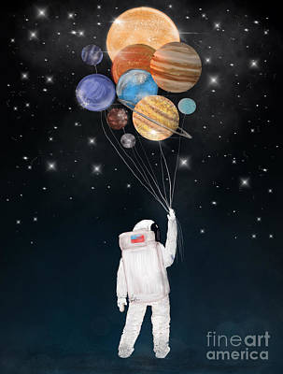
- §117.111. Art, (2b) Creative expression. The student communicates ideas through original artworks using a variety of media with appropriate skills. The student expresses thoughts and ideas creatively while challenging the imagination, fostering reflective thinking, and developing disciplined effort and progressive problem-solving skills. The student is expected to: (A) integrate ideas drawn from life experiences to create original works of art; (B) create compositions using the elements of art and principles of design; and (C) produce drawings; paintings; prints; sculpture, including modeled forms; and other art forms such as ceramics, fiber art, constructions, mixed media, installation art, digital art and media, and photographic imagery using a variety of materials.
- §113.14. Social Studies, (18) The student communicates in written, oral, and visual forms. The student is expected to: (A) express ideas orally based on knowledge and experiences; (B) use technology to create written and visual material such as stories, poems, pictures, maps, and graphic organizers to express ideas; and (C) use standard grammar, spelling, sentence structure, and punctuation.
- The learner will learn about the bigness of their universe. The learners will realize there is so much more in our atmosphere than what one can see with their own eyes. The Earth’s solar system will spark curiosity in the learners that leads them to a lifelong pursuit of learning and discovery.

Lesson Plan

Engagement/Connecting to Prior Knowledge | I will begin getting my students excited for the lesson by asking them if they like exploring? What are your favorite things to explore? Have you ever looked up into the sky and thought about what was up there? How do you get to space? I will then listen to some of my students answers and I will respond with, “Well today, we will be writing and drawing about what exists beyond our own planet earth with some help from our own imagination. So, let’s start exploring!”
Teaching Point | Today, I want to teach you that there are 8 planets in the Earth’s solar system. We will draw a picture of the Earth’s solar system as if we were an astronaut exploring space. From our drawing we will write a story about our adventure in space. I will show the artwork by Bri Buckely and explain that this is her visual representation of space.
Teach | I will begin the teaching portion by going over what makes up the Earth’s solar system. I will ask my students if they can remember the planets in order from the sun? I will begin by writing the first two planets from the sun in order. I will ask my students to verbally tell me the next planet that comes, and I will write it on the board. This will continue until we reached Neptune. I will ask them if scientist still consider Pluto a planet. Then we will go over the characteristics of each planet. We will make a graphic organizer to help organize the characteristics of each planet. Once, we have finished learning about the characteristics of the Earth’s Solar system, I will go into my demonstration by saying…  “Listen to me as I show you what we are going to be doing.  First, I am going to get a sheet of construction paper and markers and color pencils.  Then, I am going to start pretending I am an astronaut exploring space.  Then I will ask myself what have I seen in space? Have I visited all 8 planets? What did the planets look like? What do I want to focus on in my drawing – one planet or a few planets? Am I in a rocket ship or floating with a jet pack?  Then I will begin to draw what I discovered during my adventure while exploring the Earth’s solar system.  Then, I am going to flip the construction paper over.  Then, I am going to create a story about my adventure in space.  Then, I am going to review my story and make sure I used standard grammar, spelling, and complete sentences.  Finally, once I have finished, I will orally share it with the class.
Active Engagement | Now it’s your turn to try it out!  One student will hand out the construction paper to all the students. Another student will make sure each table has markers and color pencils. Once the students have all the materials they need, they will begin thinking about what their exploration looks like and what they experienced. I will be walking around to make sure no student needs any help. The students are responsible to create their image of the Earth’s solar system and write their idea in a story format. I will make sure to tell my students, “If you are stuck at all try asking your neighbor for help but if they cannot answer, I will answer your questions the best I can. There is no right or wrong answer. I want everyone to try their best and I look forward to seeing your images and hearing your story.” If I see students still stuck on their drawing, I will give them a few ideas and tell the whole class how much longer they have before they create their story. The students who volunteer will then share their work once everyone has finished.
Link/Check for understanding | I will make sure my students understood my teaching point by asking them, “Who can tell me what we practiced today?” The answer I would be looking for is not that we learned about the Earth’s solar system but how to creatively express one’s knowledge and experiences in written and visual form. I will allow a few students to come up and share with their class their creative piece of artwork and story.

Sculpture

“Untitled (Solar System), 1984 by B. Wurtz
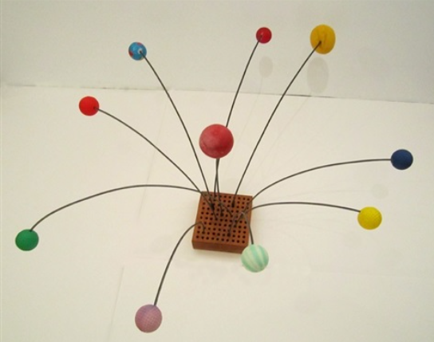
- §117.111. Art, Grade 3, Adopted 2013. (4b) Critical evaluation and response. The student responds to and analyzes artworks of self and others, contributing to the development of lifelong skills of making informed judgments and reasoned evaluations. The student is expected to: (A) evaluate the elements of art, principles of design, or expressive qualities in artworks of self, peers, and historical and contemporary artists; (B) use methods such as oral response or artist statements to identify main ideas found in collections of artworks created by self, peers, and major historical or contemporary artists in real or virtual portfolios, galleries, or art museums; and (C) compile collections of personal artworks such as physical artworks, electronic images, sketchbooks, or portfolios for purposes of self-assessment or exhibition.
- §110.5. English Language Arts and Reading, Grade 3, Adopted 2017. (12) Composition: listening, speaking, reading, writing, and thinking using multiple texts-genres. The student uses genre characteristics and craft to compose multiple texts that are meaningful. The student is expected to: (A) compose literary texts, including personal narratives and poetry, using genre characteristics and craft; (B) compose informational texts, including brief compositions that convey information about a topic, using a clear central idea and genre characteristics and craft; (C) compose argumentative texts, including opinion essays, using genre characteristics and craft; and (D) compose correspondence such as thank you notes or letters.
- The learner will make judgements about the sculpture the “Untitled (solar system)” by B. Wurtz and express how they think the sculpture was formed by developing drafts in either oral, pictorial, or written form.
Lesson Plan

Engagement/Connecting to Prior Knowledge | To get my students excited for the lesson I will bring in various household items such as ping-pong balls, tennis balls, inflated balloons, oranges, grapefruits, small pebbles, marbles, and other spherical items. I will place the objects in the art center piece. I will have my students sort them from largest to smallest. I will then let my students answer these questions: What object is heavier? Is the heaviest object the largest? How many times larger is the biggest object then the smallest object? How do you know? I will then say that the sorting you all did is like how scientist would classify the planets. Today, we will be working in groups, creating a sculpture that is representative of the planets in the solar system based on a specific scientific criterion they used to sort the planets.
Teaching Point | Today we will be working in table groups. We will create a model of the 8 planets based on our judgment of sorting and write a short informational text or argumentative text on why you arranged the planets the way you did in your sculpture.
Teach | Listen to me as I show you what we are going to be doing.  First, we are going to start generating ideas on how to sort or order the planets. We can order the planets from biggest to smallest, from nearest to farthest from the sun, or heaviest to lightest for example.  Then, I will turn to my table and discuss my ideas on sorting the planets.  Then, one member of the group will go to the art center piece and find the objects the group decided to use that best represent each of the planets.  Then, the group will create a sculpture.  Finally, each group member will write their own paper on how the group decided to arrange the planets in the sculpture the way they did. Did you see how I was able to create an idea in my head, discuss orally with my group, agree on a strategy for ordering the planets to create the sculpture and then put the idea on paper?
Active Engagement | Now it’s your turn to try it out...  I will give my students a few quiet minutes to start thinking of ideas about how to sort the planets. Then the students will be able to discuss with their group their ideas. Once the students agree as a table about how they are going to arrange the planets, they will work together and find objects that best represent each planet. They will then create the sculpture. Finally, they will conclude the activity by expressing their idea behind the sculpture on paper and making the argument on why their arrangement of the planets is valid based on the criteria they used. Each member of the group will write their own paper.
Link/Check for understanding | Today we learned that we could be scientist. We learned how to examine objects and sort them based on a criterion. We also expressed our ideas in a scientific way based on the judgements we made about each planet. We can look back at the sculpture I showed you at the beginning of class and we can conclude that we are artist as well as scientists. Who can share with me what they created and what they wrote? I will allow some students to stand up and express their judgements of the sorting of the planets and the creation of their sculpture.

Visiting Artist: Dana Mowdy Spencer

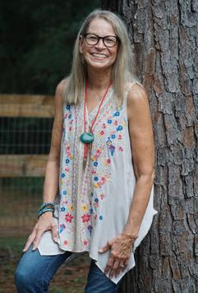
I chose Dana Mowdy Spencer as my visiting artist. Dana Mowdy Spencer works at the Conroe Art League and has her recent artwork hanging on its walls. The Conroe Art League can be contacted at (936)-756-9572. Dana Mowdy Spencer graduated from Oklahoma State University with a bachelor’s degree of Fine Arts. Dana grew up knowing she was an artist. As a young child Dana would get in trouble for drawing murals on her bedroom walls and the kitchen door. She said, “Art class was always an essential part of each school year.” Her love for animals, nature, and the outdoors are displayed in her art pieces. Interestingly, her daughter works for NASSA. Dana has insights on what it is like to explore space because of her daughter. I would invite Dana to my class by emailing her at dkspencer58@gmail.com I would explain to Mrs. Spencer that it would be an amazing opportunity for my students if she would come and share her experiences with my students and help them express their creativity. I would ask Mrs. Spencer to address fractions to discrete quantities (groups that are countable) represented in art pictures. Students would be asked to write a story problem based off their artwork. Mrs. Spencer would be assisting them in their creative Earth’s solar system paintings by giving them illustration and painting tips as well as modeling how artwork can visually display discrete quantities of objects. I chose Mrs. Spencer because she told me that she loves helping children understand art and learn how to express themselves. The experience will be beneficial for my students because they will witness a real artist modeling a piece of work, as well as having a expert provide them with different tips and ideas for their own artwork.

TEKS:
- (2b) §117.111. Art, Grade 3, Adopted 2013. Creative expression. The student communicates ideas through original artworks using a variety of media with appropriate skills. The student expresses 0thoughts and ideas creatively while challenging the imagination, fostering reflective thinking, and developing disciplined effort and progressive problem-solving skills. The student is expected to: (A) integrate ideas drawn from life experiences to create original works of art; (B) create compositions using the elements of art and principles of design; and (C) produce drawings; paintings; prints; sculpture, including modeled forms; and other art forms such as ceramics, fiber art, constructions, mixed media, installation art, digital art and media, and photographic imagery using a variety of materials.
- §111.5. Mathematics, Grade 3, Adopted 2012. (3) Number and operations. The student applies mathematical process standards to represent and explain fractional units. The student is expected to: (A) represent fractions greater than zero and less than or equal to one with denominators of 2, 3, 4, 6, and 8 using concrete objects and pictorial models, including strip diagrams and number lines; (B) determine the corresponding fraction greater than zero and less than or equal to one with denominators of 2, 3, 4, 6, and 8 given a specified point on a number line; (C) explain that the unit fraction 1/b represents the quantity formed by one part of a whole that has been partitioned into b equal parts where b is a non-zero whole number; (D) compose and decompose a fraction a/b with a numerator greater than zero and less than or equal to b as a sum of parts 1/b; (E) solve problems involving partitioning an object or a set of objects among two or more recipients using pictorial representations of fractions with denominators of 2, 3, 4, 6, and 8; (F) represent equivalent fractions with denominators of 2, 3, 4, 6, and 8 using a variety of objects and pictorial models, including number lines; (G) explain that two fractions are equivalent if and only if they are both represented by the same point on the number line or represent the same portion of a same size whole for an area model and, (H) compare two fractions having the same numerator or denominator in problems by reasoning about their sizes and justifying the conclusion using symbols, words, objects, and pictorial models.

Art center floor plan and center information –

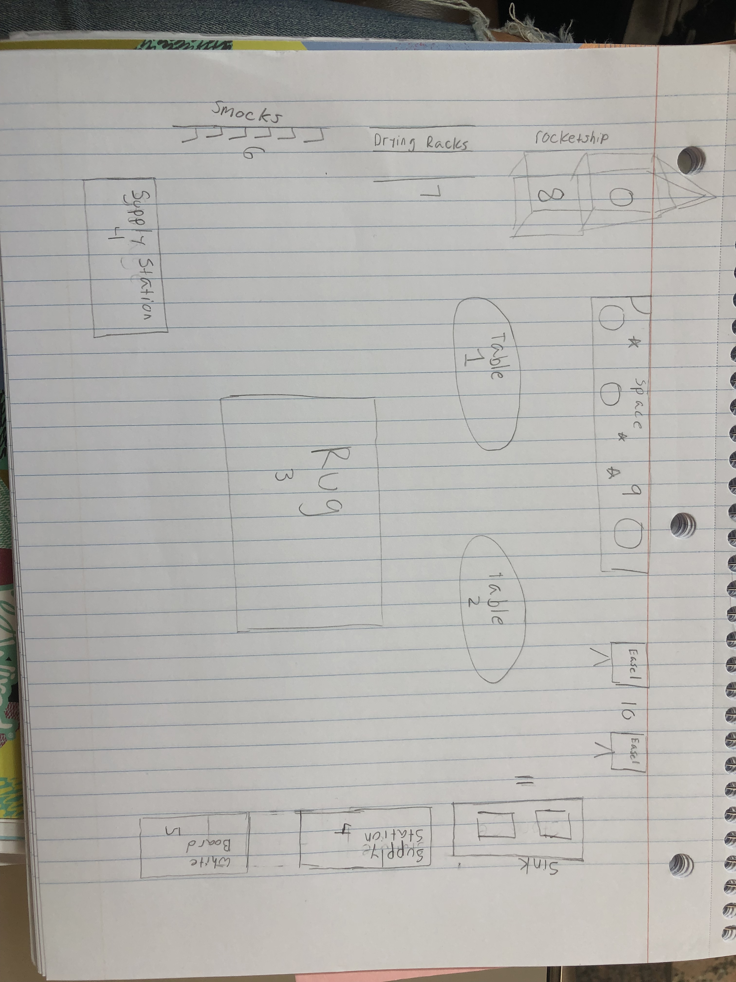

1, 2 – Tables. Students will sit together at each table in groups of four. They can ask each other questions about the assignment and help each other come up with creative art pieces.

3 - Rug. The rug is where the students can gather and play with different space toys on the rug.

4 - Supply station. The supply station will be filled with all different art supplies that the students can use to make their artwork. All the supplies will be sorted into individual bins; the bins will be labeled with big words indicating what is inside the bin. Some of the art supplies inside the bins will include: construction paper, pencils, markers, tape, colored pencils, crayons, glue sticks, construction paper, canvases, Q-tips, plastic and paper cups, and much more.

5 - White Board. The white board is for two students to enjoy while writing or drawing using expo markers. They white board give students the freedom to create anything they would like and allows them to erase easily. The projection board is for the teacher to teach a lesson and allows the students to follow along visually.

6- Smock Rack. The smock rack is a coat rack that contains different smocks for students to put on while they are painting. This helps them avoid getting paint on their clothes.

7 - Drying Rack. The drying rack is used to hang up their art pieces so they can dry and be safe from getting ruined.

8- Rocket Ship. The Rocket Ship makes the center more engaging. The students can go inside of it and use their imagination. They can pretend that they are heading to space and about to explore the different planets.

9-Poster Board. This is where the students can see all 8 planets and the stars in space. The teacher can add the student’s art work to the banner also.

10 – Easels. The standing easel will be for one student at each easel at a time. The students will be able to bring papers, paint and paintbrushes to the easel. Since only one person is allowed at each easel at a time, student will have the ability to create privately.

11 – Sink. The sink is for students to wash their hands and brushes wherever they are done with their art pieces.

Skills I want the students will develop-

I want the students to develop their creativity, free-thinking, critical thinking, self-confidence, and curiosity. I want students to know and believe that mistakes are okay. Students will learn how to use different art supplies appropriately as well as how to clean up after themselves. My goal is for students to be able to express their ideas on how to create a representative of the Earth’s solar system using different art material in a creative way. I want the students to be respectful to the materials and their classmates. I want the students to learn how to work with one another using the right tone and voice level, as well as being able to come to a consensus on how to solve a task given them. I want my students to work together to help develop their social skills. I want the students to feel comfortable and confident in their artwork that they can share their project with the class and/or hang it up on the wall. Also, I want my students to encourage one another and provide respectful and helpful feedback if a student asks another student for advice. Through all the projects, the students should develop a deeper knowledge about the Earth’s solar system.

Basic materials needed for the center-

Construction paper, markers, crayons, colored pencils, erasers, paint, paint brushes, paint cups, canvases, smocks, white boards, expo markers, glue sticks, scissors, ping-pong ball, tennis ball, inflated balloon, grapefruit, small pebbles, marbles, and other spherical items.

The purpose of the art center is for students to be encouraged to use their creative minds to create projects that express their thoughts and ideas. It is also important for students to play around with different objects and use their five senses. The art center is also a perfect place for students to find all sorts of materials that they can use in their artwork that they may not have thought to use on their own without seeing it on the table. It is very important for student to have guidelines that provide a framework that allows them to create. Copying a set project does not allow students to express their creativity, but no guidelines leads to chaos and the inability to be creative.

Guidelines-
- Students will respect one another and will not draw or mess up each others art piece.
- Students will respect the teacher’s rules.
- Students will follow the all the school and classroom rules.
- Students will respect all the materials and use them properly.
- Students will make sure all the supplies they used are properly put back in the right place.
- Students will use the appropriate amount of paint, glue, and other objects when working.
- Students will make sure all the caps of the markers, paints, and glue are sealed and applied properly.
- Students will wash their hands and the paintbrushes when they finish.
- Students will place their artwork on the drying rack when finished.

Assessment instrument –

Formative- Teacher will observe the students before the activity when asking the students about the Earth’s solar system. The teacher will also observe the students when the volunteer comes up to the front and shares his or her art piece and story. While doing the assignment, the teacher will observe the students discuss among each other about the characteristics of the planets. The teacher will also observe the students asking their friend for help. The teacher will observe the students to make sure they fully understand the assignment and follow the directions.

Summative- The teacher will access the student’s sculpture and information or argumentative paper as a summative assessment. The teacher will use the rubric below to make sure the students present all of the planets and arrange them based on the sorting criteria they decided to use. The teacher will also be assessing the students by making sure they followed directions carefully and that their work is legible.

Rubric |  |  |  | Bonus Points
Points | 3 | 2 | 1 | 1
All Planets Present | All eight planets are present in their artwork and in their story. | Five or more planets are presented in their artwork and story. | Three or less planets are present in their artwork and story. | If the students add Pluto to their artwork and in their story.
Planets ordered based on specified characteristics decided by the group | All eight planets are presented in the correct relationship. | Five planets or more are presented in the correct relationship. | Three or less planets are presented in the correct relationship. | Pluto is presented in the correct relationship.
Explanation of their ordering for the planets | All planets were addressed based on the characteristic chosen. | At least five planets were addressed based on the characteristic chosen. | At least three planets were addressed based on the characteristic chosen. | Pluto was included in the discussion.
 |  | Total Points=

